Payroll Management System
Technology Stack: Python + MongoDB

1. INTRODUCTION
1.1 Purpose of the Document
This document defines the functional requirements, non-functional requirements, system analysis, constraints, and feasibility of the Payroll Management System. It serves as a single source of truth for developers, testers, and stakeholders.

1.2 Project Overview
The Payroll Management System is a desktop-based application developed using Python for application logic and GUI, with MongoDB as the backend database.
The system automates employee payroll processing, attendance tracking, statutory deductions, and payslip generation.

1.3 Scope of the System
The system will:
- Maintain employee records
- Manage attendance and leave
- Calculate salaries and statutory deductions
- Generate payslips and payroll reports
- Store all payroll data securely in MongoDB
The system will not initially include:
- Online banking APIs
- Government portal integration
- Cloud-based web access

2. SYSTEM ANALYSIS
2.1 Existing System (Manual / Semi-Automated)
Most organizations currently rely on:
- Excel sheets
- Manual attendance registers
- Manual salary calculations
Problems with Existing System
- High probability of calculation errors
- No centralized data storage
- Time-consuming payroll cycles
- Poor auditability
- Difficult compliance tracking

2.2 Proposed System
The proposed system is a fully automated payroll application that:
- Uses structured payroll rules
- Stores data securely in MongoDB
- Generates accurate salary outputs
- Provides professional payslip PDFs
- Reduces human dependency and errors

2.3 System Architecture Overview
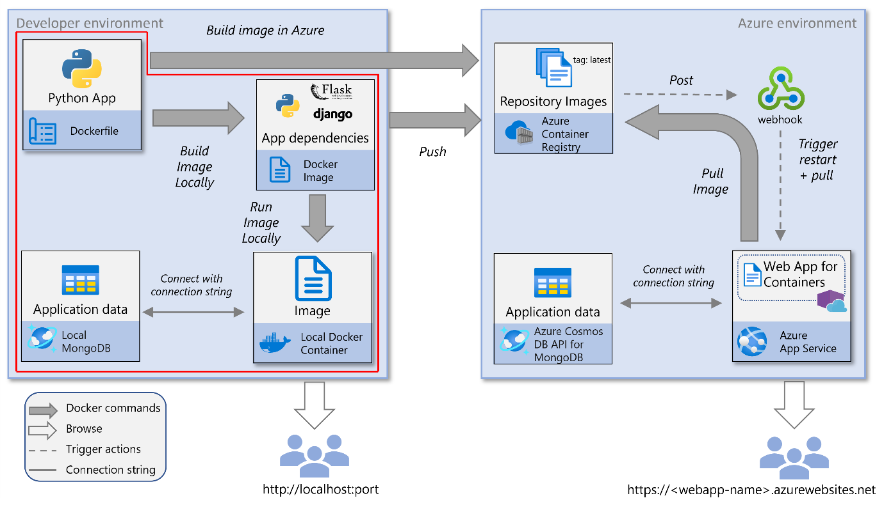
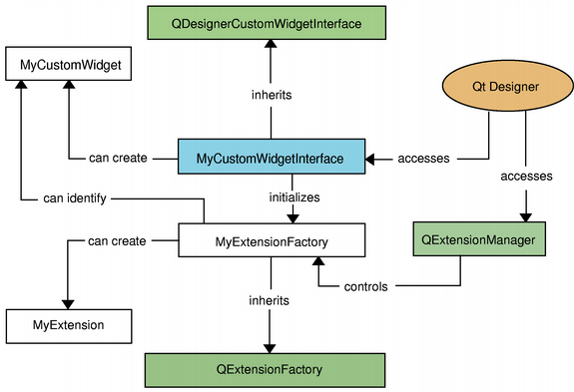

Architecture Pattern: Layered Architecture
GUI Layer (PySide6)
↓
Service Layer (Business Logic)
↓
Repository Layer (MongoDB Access)
↓
MongoDB Database

3. FUNCTIONAL REQUIREMENTS
3.1 User Authentication
- Secure login for Admin/HR users
- Role-based access control
- Encrypted password storage

3.2 Employee Management
- Add, update, delete employee records
- Store personal, professional, and bank details
- Activate/deactivate employees

3.3 Attendance Management
- Monthly attendance entry
- Loss of Pay (LOP) tracking
- Overtime recording
- Leave management

3.4 Salary Structure Management
- Define salary components:
  - Basic
  - HRA
  - Allowances
- Salary structure stored per employee

3.5 Payroll Processing
- Monthly payroll generation
- Automatic calculation of:
  - Gross salary
  - PF
  - ESI
  - Professional Tax
- Net salary computation
- Payroll record locking after generation

3.6 Payslip Generation
- PDF payslip generation
- Includes:
  - Company details
  - Employee details
  - Earnings & deductions
  - Net payable salary

3.7 Reports & Export
- Payroll summary reports
- Employee-wise salary history
- Excel export functionality

4. NON-FUNCTIONAL REQUIREMENTS
4.1 Performance
- Payroll processing should complete within seconds for up to 500 employees
- MongoDB queries must be indexed for performance

4.2 Security
- Password hashing (bcrypt)
- Role-based access
- No direct GUI-to-database access
- Secure MongoDB connection

4.3 Reliability
- Consistent payroll calculations
- Data integrity checks
- Backup-friendly database design

4.4 Usability
- Simple and intuitive desktop UI
- Minimal training required
- Clear error messages

4.5 Maintainability
- Modular Python code
- Clear separation of GUI, services, and database layers
- Easy rule updates (PF, ESI, PT)

4.6 Portability
- Runs on Windows (primary)
- Portable to Linux/macOS with minimal changes

5. TECHNOLOGY REQUIREMENTS
5.1 Software Requirements
Component | Technology
Programming Language | Python 3.10+
GUI Framework | PySide6
Database | MongoDB
Database Driver | PyMongo
PDF Generation | ReportLab
Excel Export | openpyxl
Packaging | PyInstaller

5.2 Hardware Requirements
Resource | Minimum
Processor | Dual Core
RAM | 4 GB
Storage | 500 MB
OS | Windows 10+

6. DATABASE DESIGN OVERVIEW
Core Collections
- employees
- salary_structures
- attendance
- payroll
Database Characteristics
- Document-based
- Flexible schema
- Indexed fields for reporting

7. BUSINESS RULES
- PF = 12% of Basic Salary
- ESI applicable if Gross ≤ ₹21,000
- Professional Tax based on state rules
- LOP deduction based on working days
- Payroll once generated cannot be edited

8. ASSUMPTIONS & CONSTRAINTS
Assumptions
- Single organization usage initially
- Payroll rules are configurable
- Attendance data is entered manually
Constraints
- Desktop-only application
- No third-party API dependency
- MongoDB must be available

9. FEASIBILITY STUDY
9.1 Technical Feasibility
✔ Fully feasible using Python and MongoDB
9.2 Economic Feasibility
✔ Open-source libraries minimize cost
9.3 Operational Feasibility
✔ Easy adoption for HR/admin staff

10. FUTURE ENHANCEMENTS
- Multi-company support
- Cloud synchronization
- Biometric attendance integration
- GST/TDS modules
- Web & mobile version

11. CONCLUSION
The proposed Payroll Management System is a robust, scalable, and efficient desktop application built entirely with Python and MongoDB. It eliminates manual payroll inefficiencies while providing accuracy, security, and professional reporting.

